Name(s)_______________________________________________ Period ______ Date ___________________

|  |  |  |
| --- | --- | --- |
|  | **Activity Guide - Functions Make** |  |

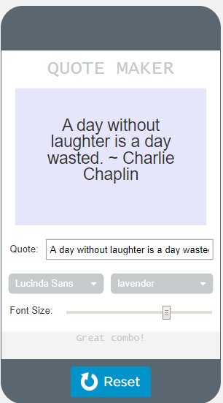

"quoteInput"

"colorOutput"

"colorInput"

"fontFamilyInput"

"feedbackOutput"

"quoteOutput"

"fontSizeInput"

**Step 1 - Try the app**

* Try many of the different options.
* Pay attention to what is happening on the screen when you move the slider or choose an item from the dropdown.
* When does the screen update?
* What happens if you choose lavender and Lucinda Sans from the dropdowns? Try choosing lightreen and moving the slider until you receive feedback.

Discuss with a Partner

* What does this app do?
* What are the inputs?
* What are the outputs?
* How could a function be used in this app?

**Step 2 - Plan**

**Variables:** Fill in the table below for each variable you'll need to create.

|  |  |
| --- | --- |
| **Variable Name** | **What the Variable Stores** |
| *color* | *the background color the user selects* |
| *fontFamily* |  |
|  |  |
|  |  |

**Conditionals:** An if-else-if statement is used to check if certain options have been selected. Set up the conditional below using the variables you created above.

* Note: You can be creative here! Choose your own combinations and feedback messages.

|  |
| --- |
| if (color == _______________ && fontFamily == _______________ ){  setText("feedbackOutput", ______________________________);  } else if ( _______________ == _______________ && _______________ == _______________ ){  setText("feedbackOutput", ______________________________);  } else {  setText("feedbackOutput", ______________________________);  } |

**Functions:** Consider what should be included in a function that updates the screen. Write out your plan below.

Things to think about:

* What elements on the screen need to be updated using the variables above?
* Does the conditional above belong in the function? Why or why not?
* When will the function be called?

|  |  |
| --- | --- |
|  | Review the **updateScreen() Pattern** to help you plan your function. |

**Inputs:** What are the inputs for the app? These will all be turned into onEvents.

|  |  |  |
| --- | --- | --- |
| **Input** | **Action** | **Result** |
| *"quoteInput"* | *input* | *The text on the screen appears, one character at a time as it's typed.* |
| *"fontFamilyInput"* | *change* |  |
|  |  |  |
|  |  |  |

**Step 3 - Write Your Code**

* Write the code for the app, using your plan above and the comments provided in Code Studio to help
* Step You Can Follow
  + Create all the variables from your table above.
  + Give your variables a starting value using the assignment operator (=)
  + Create a conditional that checks if various options are selected.
  + Create a function that updates the screen.
  + Create event handlers (onEvent) for the inputs in your table above
  + Use your debugging skills to identify unexpected behavior and fix your program
  + Comment your code as you go, explaining what each event handler and function does
* Extension Ideas
  + Create a dropdown with image names and decorate your quote!

**Step 4 - Submit**

Before your submit check the rubric below to make sure your program

|  |  |  |  |  |
| --- | --- | --- | --- | --- |
| **Category** | **Extensive Evidence** | **Convincing Evidence** | **Limited Evidence** | **No Evidence** |
| Input | onEvents are created for all the required inputs. | onEvents are created for most of the inputs. | onEvents are created for some of the inputs. | onEvents are not created for any inputs. |
| Storage: Variables | Variables are created and appropriately used for all pieces of information used in the app. | Most information is stored in a variable and appropriately updated throughout the app. | Some information is stored in a variable and appropriately updated throughout the app. | There are no variables which store the necessary information for the app to work correctly. |
| Code: Conditionals | An if-else-if statement is used which correctly checks if certain options have been selected and displays feedback. | An if-else-if statement is used that partially checks if certain options have been selected and displays feedback. | An if-else statement or an if statement is used that checks if one option has been selected. | No conditional is present. |
| Code: Functions | A function is used which correctly updates all output elements. The function is called in all onEvents. | A function is used which correctly updates most of the output elements. The function is called in all onEvents. | A function is used which updates some of the output elements or the function is only called in some onEvents. | There is no function which updates the screen. |
| Code runs without errors. | No errors are present in the required code. | One or two errors are present in the required code. | Three or four errors are present in the required code. | More than four errors are present in the required code. |
| Coding Comments | Comments are used to correctly explain the purpose and function of all onEvents and functions. | Comments are used to explain the purpose and function of most onEvents and functions. | Comments are used to explain the purpose and function of some onEvents and functions. | Comments are not present. |